Superstore Sales Analysis and Forecasting Dashboard

Project Report

Prepared By
Manoj Kumar S

Page 1 – Introduction
The Superstore Sales Analysis and Forecasting Dashboard project was developed to analyze retail sales data and generate business insights using Python, PostgreSQL, Power BI, and Machine Learning.
The project focuses on sales trends, customer behavior, product performance, regional analysis, and future sales prediction. The dashboard helps businesses understand performance and make better decisions.

Page 2 – Objectives

Objectives of the Project
- To clean and preprocess retail sales data.
- To analyze customer purchasing behavior.
- To identify top-performing products and regions.
- To create an interactive Power BI dashboard.
- To perform SQL-based business analysis.
- To predict future sales using Machine Learning.

Page 3 – Tools and Technologies Used
Tool | Purpose
Python | Data Cleaning and EDA
PostgreSQL | SQL Analysis
Power BI | Dashboard Visualization
Pandas | Data Manipulation
Matplotlib | Visualization
Scikit-learn | Machine Learning
Jupyter Notebook | Development Environment

Page 4 – Dataset Description
The project uses the Superstore retail sales dataset.

Important Columns
Column Name | Description
Order_ID | Unique order ID
Customer_Name | Customer name
Segment | Customer segment
Region | Sales region
Category | Product category
Sub_Category | Product sub-category
Product_Name | Product name
Sales | Sales amount
Year | Order year
Month | Order month

Page 5 – Data Cleaning and Preprocessing
Data cleaning was performed using Python.

Steps Performed
- Handled missing values.
- Removed duplicate records.
- Converted date columns into datetime format.
- Created Year and Month columns.

Example Code
pd.to_datetime(df['Order_Date'])
df['Year'] = df['Order_Date'].dt.year
df['Month'] = df['Order_Date'].dt.month

Page 6 – Exploratory Data Analysis (EDA)
EDA was performed using Pandas and Matplotlib.

Analysis Performed
- Monthly sales trend analysis
- Region-wise sales analysis
- Category-wise sales analysis
- Segment-wise sales analysis
- Product-wise sales analysis

Visualizations Created
- Line Charts
- Bar Charts
- Donut Charts
- Trend Graphs

Page 7 – SQL Analysis Using PostgreSQL
PostgreSQL was used for business-oriented analytical queries.

SQL Concepts Used
- SELECT
- GROUP BY
- ORDER BY
- SUM()
- AVG()
- COUNT()

Sample Query
SELECT Region,
SUM(Sales) AS Total_Sales
FROM orders
GROUP BY Region
ORDER BY Total_Sales DESC;

Page 8 – Power BI Dashboard
An interactive Power BI dashboard was developed to visualize business insights.

Dashboard Features

KPI Cards
- Total Sales
- Total Orders
- Average Sales

Visualizations
- Sales by Region
- Sales by Category
- Sales by Segment
- Monthly Sales Trend
- Top Products by Sales

Slicers
- Region
- Category
- Segment
- Year

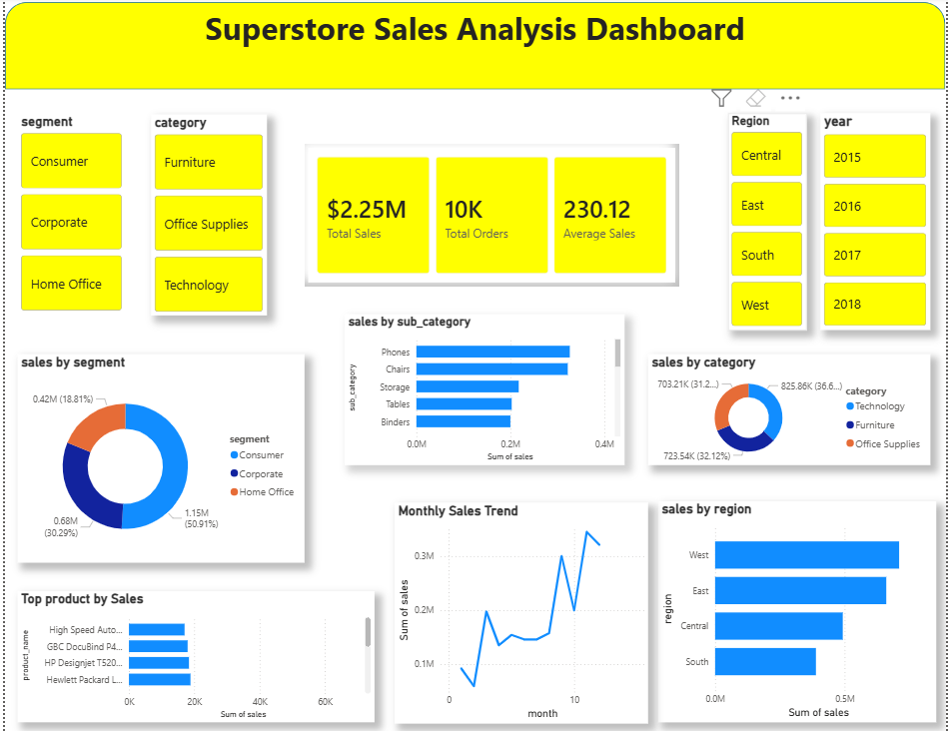

Page 9 – Machine Learning Forecasting
Basic Machine Learning forecasting was implemented using Linear Regression.

Objective
To predict future monthly sales trends.

Process
- Monthly sales data preparation
- Training Linear Regression model
- Predicting future sales
- Plotting forecast graph

Libraries Used
- Scikit-learn
- Matplotlib

Page 10 – Conclusion and Future Enhancements

Conclusion
The project successfully demonstrated the complete Data Analytics workflow including data cleaning, SQL analysis, dashboard creation, and sales forecasting.
The dashboard provides meaningful insights into sales performance, customer behavior, and product trends.

Future Enhancements
- Advanced forecasting models
- Multi-page dashboards
- Real-time database integration
- Advanced DAX measures
- Cloud deployment

Project Outcome
This project improved practical skills in:
- Python
- PostgreSQL
- Power BI
- SQL
- Machine Learning
The project can be used as a portfolio project for Data Analyst interviews and placements.

